Alarm contacts series
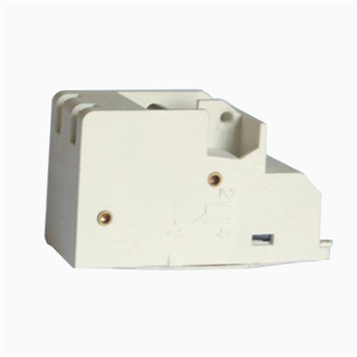

Alarm contacts application:
The alarm contacts is used for alarm open action of current ,and under voltage of circuit and equipment.

Alarm contacts size:
1N/O and 1N/C

>> Wiring diagram of Auxiliary contacts:
State of MCCB | State of alarm contacts | diagram of wiring
Close position | 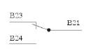 | 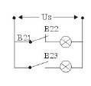
Open position | 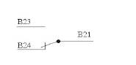 | 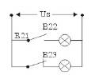

CM1-63BC  CM1, TM30(NF30)  CDM1-63A | CM 1-100BC  CM1, TM30(NF30)  CDM1-100A | CM 1-225BC  CM1, TM30(NF30)  CDM1-225A /250A

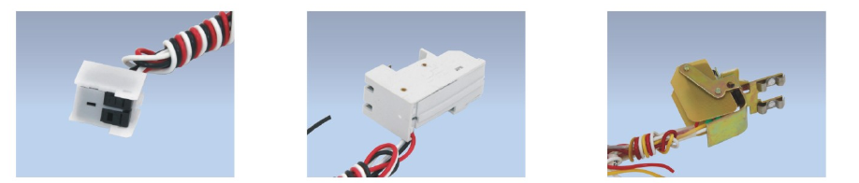
DAM1-125/160BC  DAM1(ABB)-125,160A | DAM1-250/400BC  DAM1(ABB)-250A,400A | DZ20-100BC  DZ20-100A

DZ20-225BC  DZ20-225A | DZ20-225BC  DZ20-225A | DZ20-400BC  DZ20-400A
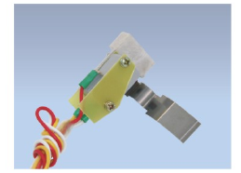
DZ20-630BC
DZ20-630A

