Auxiliary and alarm contacts series
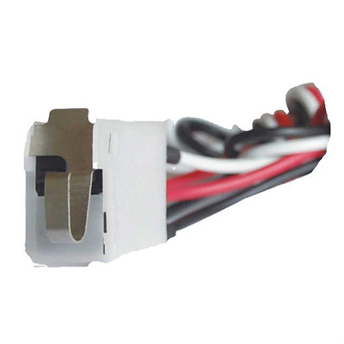

>> Application:
The auxiliary contacts is intended for automatical controlling of the auxiliary circuit of MCCB,and open action of current,and under voltage of circuit and equipment.

>> Auxiliary and alarm contacts size:
1N/O and 1N/C+1alarm contact
2N/O and2N/C+1alarm contact

>> Wiring diagram of Auxiliary and alarm contacts:
State of MCCB | State of alarm contacts | diagram of wiring
Close position | 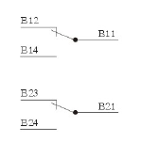 | 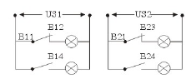  Explanation Us1 is auxiliary power  Us2 is alarm power
Open position | 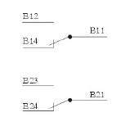 | 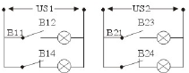  Explanation Us1 is auxiliary power  Us2 is alarm power

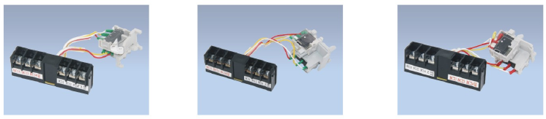
CM1-63FB  CM1, TM30(NF30)  CDM1-63A | CM 1-100FB  CM1, TM30(NF30)  CDM1-100A | CM 1-225FB  CM1, TM30(NF30)  CDM1-225A

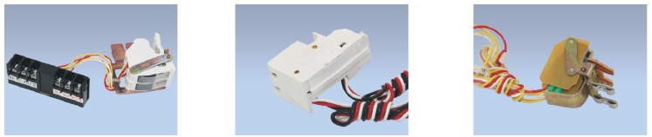
CM1-400FB  CM1, TM30(NF30)  CDM1-400 | DAM1-250/400FB  DAM1(ABB)-250A,400A | DZ20-100FB  DZ20-100A

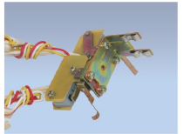

DZ20-225FC
DZ20-225A

