Electrical operating mechanism series
>> DAM1(ABB) Electrical operating mechanism

The electrical operating mechanism is available remote close of MCCB
The types of electrical operating mechanism are shown in table 2

>> Types of electrical Operating Mechanism: Table 2
Rated current of frame size Inm | Types of electrical Operating Mechanism
Rated current of frame size Inm | CD1 | CD2 | CD3 | CD
63A | - | CD2-63 | - | -
100A | - | CD2-100 | - | -
160A | - | CD2-160 | - | -
250A | CD1-250 | CD2-250 | - | CD-250
400A | CD1-400 | - | - | CD-400
630A | - | - | CD3-630 | CD-630
800A | - | - | CD3-800 | CD-800
1250A | - | - | CD3-1250 | CD-1250
1600A | - | - | CD3-1600 | CD-1600

>> Description of selection:
Customer can make selection of the electrical operating mechanism according to the price and types e.q.If you want to order CD type 630A electrical operating mechanism ,having rated operational voltage AC 220V with total quantities of 12 ,you should write in this way in your order :CD-630A/AC220V,12sets.

>> CD1 type electrical operating mechanism
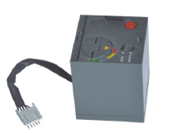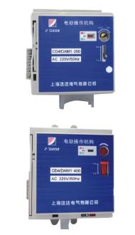

CD1 type electrical operating mechanism

Direct-acting and manual close/open of MCCB
Equipment with emergency opening button
Customer can fit padlock on it for MCCB in open position (up to a max of 3 padlock with max 6mm dia).It can be supplied witch.
One key and one lock for one MCCB
One key and two lock for three MCCB
Two key and three lock for three MCCB
Suitable for MCCB
Inm=250A
Inm=400A
The specific type should be stated clearly in your order
Selectable accessories

>> Characteristic
Characteristic of CD1 type electrical operating mechanism Table 3
Electrical accessories |  |  |  | Electrical operating mechanism
Range of supply voltage |  |  |  | (0.85-1.1)X Us
Rated control supply voltage | Power supply | AC 50Hz |  | 220V | 380V
Rated control supply voltage | Power supply | Power loss | Irrush power consumption | 510VA | 510VA
Rated control supply voltage | Power supply | Power loss | Normal load | 360VA | 360VA
Rated control supply voltage | Power supply | DC |  | 110V | 220V
Rated control supply voltage | Power supply | Power loss | Irrush power consumption | 510W | 510W
Rated control supply voltage | Power supply | Power loss | load | 360W | 360W
Closing time |  |  |  | 0.1S
Opening time |  |  |  | 0.1S

CD2 type electrical operating mechanism

>> Direct-acting and manual close/open of MCCB
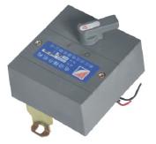Equipment with emergency opening button Suitable for MCCB
Inm=63A Inm=100A Inm=160A Inm=250A
The specific type should be stated clearly in your order
Selectable accessories

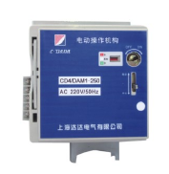

CD2 type electrical operating mechanism

