Plug-in version accessory
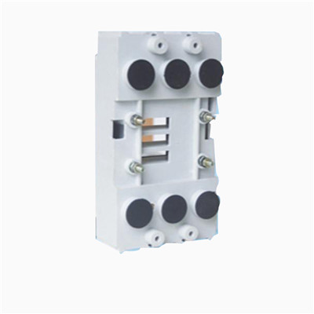

>> CM 1 Plug-in version accessory
Type | Scope of application | Specification and quantities | Contact pin | Arc-isolation plate and quantities | Plug-in version install using hexagonal screw and quantities | Circuit breaker install using screw and quantities | Contact pin fixed screw and quantities | User bind the board install using screw and quantities
63 Type plug-in version | CM1-63,NM1-63,CDM1-63,TM30-63 | 1 | 6 | 4 | 4-M6X23 | 4-M3X18 | 6-M5copper nut | 6-M5X10
100 Type plug-in version | CM1-100,NM1-100,CDM1-100,TM30-100 | 1 | 6 | 4 | 4-M6X23 | 4-M4X45 | 6-M6X14 | 6-M6X12
225 Type plug-in version | CM1-225,NM1-225,CDM1-225,TM30-225 | 1 | 6 | 4 | 4-M5X23 | 4-M4X45 | 4-M6X16 | 6-M8X16
400Type plug-in version | CM1-400,NM1-400,CDM1-400,TM30-400 | 1 | 6 | 4 | 4-M8X40 | 4-M6X45 | 4-M8X35 | 6-M10X20
630 Type plug-in version | CM1-630,NM1-630,CDM1-630,TM30-630 | 1 | 6 | 4

1.63Type circuit breaker for distribution using Plug-in version installation drawing installation and overall size
2.100Type circuit breaker for distribution using Plug-in version installation drawing installation and overall size
3.225Type circuit breaker for distribution using Plug-in version installation drawing installation and overall size
4.400Type circuit breaker for distribution using Plug-in version installation drawing installation and overall size
>> Hickey series
Annexe of DM1(ABB) circuit breaker series

Installation mode Table 7
Rated current of frame size Inm | Installation mode
Rated current of frame size Inm | Plug-in version |  | Draw-out version
Rated current of frame size Inm | 3P | 4P | 3P | 4P
63A | £ | £ | - | -
100A | £ | £ | - | -
160A | £ | £ | - | -
250A | £ | £ | £ | £
400A | £ | £ | £ | £
630A | - | - | £ | £
800A | - | - | £ | £
1250A | - | - | £ | £
1600A | - | - | £ | £

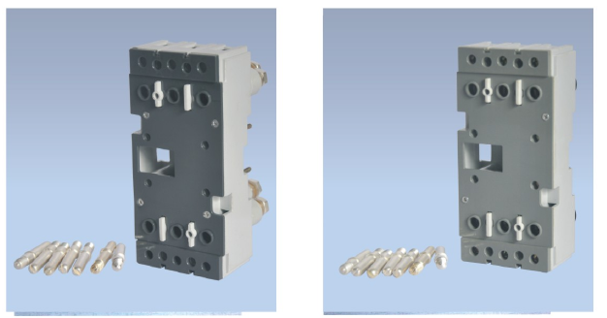
DAM1(ABB)-125APlug-in version DAM1(ABB)-160APlug-in version
DAM1(ABB)-250A DAM1(ABB)-400A DAM1(ABB)-400A
Plug-in version Plug-in version Plug-in version
(3P front terminals) (3P rear terminals)
DAM1(ABB)-400A DAM1(ABB)-400A DAM1(ABB)-630A
Plug-in version Plug-in version Plug-in version
(4P front terminals) (4P rear terminals)

