DAB7-63 Nova series Miniature Circuit breaker(MCB)
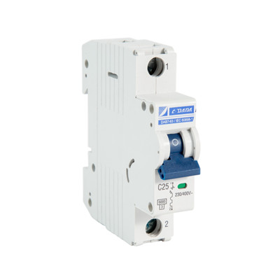

>> Introduction

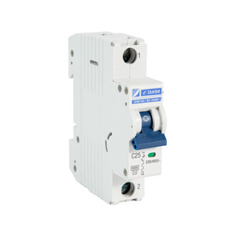 | Miniaturecircuit breakersDAB7-63Hare intended for providing automatic power source cut-off under excess currents.They are recommended for use in group panels (apartment and floor) and distribution boards of residential, domestic, public and administrative buildings.  64 items per 8 rated currents ranging from 6 to 63 A.  This MCB has been obtained ASTA, SEMKO,CB,CE certificate.

>> Advantages

· Two types of overcurrent protection – thermal and electromagnetic.
· High Breaker capacity 6/10KA
· Independent contact position indicator.
· DIN rail latch with a double fixed position.
· Wide range of operating temperatures from –40 to +50° С.
· Wide engagement lever with improved contact area.
· Notches on terminal clamps lower thermal losses and boost the mechanical stability of connection.

Technical Features

MCB DAB7-63
For protection of general power distribution (IEC/EN 60898-1) |  |  |  | 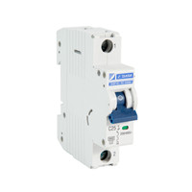 | 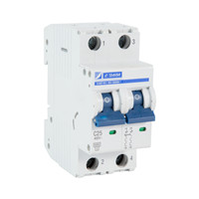 | 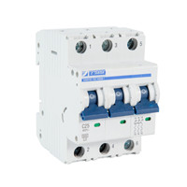 | 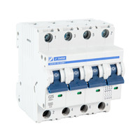
Poles |  |  |  | 1P | 2P | 3P | 4P
Electrical performance
Functions |  |  |  | short circuit protection,overload protection,isolationg,control
Rated frequency f (Hz) |  |  |  | 50-60Hz
Rated working voltage Ue V AC |  |  |  | 230/400 | 400
Rated current In(A) |  |  |  | 6,10,16,20,25,32,40,50,63
Rated insulated voltage Ui (V) |  |  |  | 500
Impulse withstand voltage UimpkV |  |  |  | 4
Instantaneous tripping type |  | DAB7-63N |  | B/C/D
 |  | DAB7-63H |  | B/C/D
Rated short circuit Icn(kA) |  | DAB7-63N |  | 6
 |  | DAB7-63H |  | 10
Release type |  |  |  | Thermal magnetic type
Service life(O~C) | Mechanical |  | Actual value | 20000
Service life(O~C) |  |  | Standard value | 4000
Service life(O~C) | Electrical |  | Actual value | 8000
Service life(O~C) |  |  | Standard value | 4000
Connection and installation
Protectiom degree |  |  |  | IP20
Wire mm² |  |  |  | 1~35
Working temperature |  |  |  | -5～+40℃
Resistance to humidity and heat |  |  |  | Class 2
Altitude above sea |  |  |  | ≤2000
Relative humidity |  |  |  | +20℃,≤90% ;+40℃,≤50%
Pollution degree |  |  |  | 2
Installation environment |  |  |  | Avoid obvious shock and vibration
Installation class |  |  |  | Class II , Class III
Mounting |  |  |  | DIN35 rail
Combination with accessories
Auxiliary contact |  |  |  | Yes
Alarm contact |  |  |  | Yes
Shunt release |  |  |  | Yes
Undervoltage release |  |  |  | Yes
Auxiliary contact+Alarm contact |  |  |  | Yes
Dimensions(mm)(WxHxL) |  |  | a | 18 | 36 | 54 | 72
 |  |  | b | 80 | 80 | 80 | 80
 |  |  | c | 72 | 72 | 72 | 72

>> Why choose us?

1. We are the leading manufacture for 30 years. Our company founded in 1986, develop very fast during 30 years.
2. The Group, comprising 3 factories, owns a production area of 52,400m² and employs more than 500 staff. we have invested nearly ten million yuan in order to expand our operation and upgrade our workshops.
3. Factory audited by INTERTEK,DEKRA&GMC
4. Having obtained CB,CE,SEMKO,KEMA, ASTA,ROHS,SASO,CCC global certificate.
5. We have professional R & D team, have standard development process. Can provide excellent customized service.
6.We produce MCB by automatic production line.
7.We can provide free samples, and, we have report for each samples, you can check our quality very well before place official order.
8. We are an intelligent company, We have OA system, ERP system, …… , that can help us to management, control quality efficiently…
8.World famous electricity Power Gen exhibition
Our exhibition covers the world, Dubai, Brazil, Russia, Hanover, Egypt, Austria,Iran, Mexico and other professional power exhibitions

>> FAQ

Q: How long is your delivery time?
A: Generally it will take 25 days upon receipt of order confirmation.If it is urgent order,we’ll negotiate to plug your order first but its better inform us as earlier as you can.

Q: Do you provide samples ? is it free or extra ?
A:The sample are free of charge, freight cannot be for free; After you order it, we can charge off from mass orders.

Q: What is your terms of payment ?
A: We accept TT,30% deposit and 70% balance against copy of BL
B. L/C at sight

Q:Can you accept OEM our brand ?
A: We accept OEM your brand, but it depends on your order quantity.

Q:What is your main market?Turnover?
A:Our main market is middle east,Europe,and turnover is roughly 20 million
USD per year.

Q:Do you have interest to do our own design items?
A:Absolutely!We have big interest!

Q:How many staffs in your company?
A:Roughly 300 in workshop, and 10 inspectors.

If you have any further questions, please let us know.

