Modular distribution box (BE series)
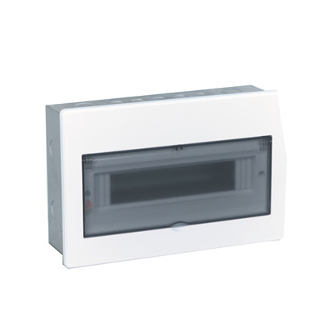
>> Introduction
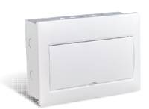 | The cover is double-curved and designed with a dewy,  simple and elegant appearance.

Technical Specification
Product series: embedded mounting distribution box/surface mountingdistribution box
Ways:4way, 7way, 10way, 12way, 14way, 16way, 18way, 20way, 24way(embedded mounting), 28way, 40way
Products: 1.embedded mounting
BEP-A 104, BEP-A 107, BEP-A 110, BEP-A 112. BEP-A 114, BEP-A 116, BEP-A 118, BEP-A 120,
BEP-A124, BEP-A228, BEP-A240
2.surface mounting
BEP-M 104, BEP-M 107, BEP-M 110, BEP-M 112, BEP-M 114, BEP-M116, BEP-M 118, BEP-M 120,
BEP-M 228, BEP-M 240
Box base material: high-quality cold-rolled plate, electrostatic powder coated
single row embedded-mounting box dimension(width*height):(4way)143x75mm,(7一20way)192x75 mm,
(24way)230x90mm
Cover material: high-quality ABS for cover base and white movable door, high-quality PC for transparent movable door,
Cover installation: fixed with screw
Box installation: 1 .embedded mounting 2. Surface mounting
Way size: 18 mm (standard width)
Terminal cross-section dimension:①4~20way 6 x 10mm
②24~ 40way 6.4 x 12mm
Rated voltage(V):~AC400V( ±20%) 50~60HZ
Rated current/Max. Current input:①55A(4~20way) 6 x 10mm
②63A(24~40way) 6.4 x 12mm
Product standard: GB17466.1-2008, GB17466.24-2008
Ingress protection: IP40

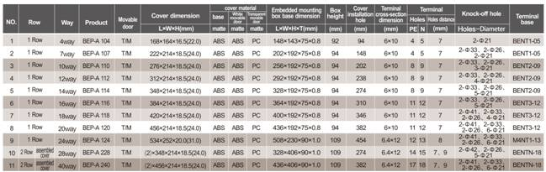
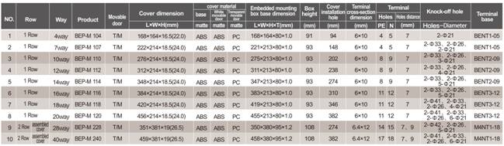

> Packing information
Specification & Description |  | Photo | Carton  L*W*H（cm) | (PCS/CTN)
Distribution Box
BE-M104 | Surface mounting | 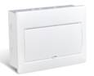 | 505×190×360 | 10
BE-M107 | Surface mounting |  | 520×245×465 | 10
BE-M110 | Surface mounting |  | 520×300×465 | 10
BE-M112 | Surface mounting |  | 520×335×465 | 10
BE-M114 | Surface mounting |  | 520×235×375 | 5
BE-M116 | Surface mounting |  | 520×235×415 | 5
BE-M118 | Surface mounting |  | 520×235×450 | 5
BE-M120 | Surface mounting |  | 520×235×485 | 5
BE-M228 | Surface mounting |  | 445×165×410 | 1
BE-M240 | Surface mounting |  | 445×165×520 | 1
BEP(2013)-A 104 | Embedded mounting | 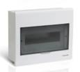 | 505*190*360 | 10
BEP(2013)-A 107 | Embedded mounting |  | 520*245*465 | 10
BEP(2013)-A 110 | Embedded mounting |  | 520*300*465 | 10
BEP(2013)-A 112 | Embedded mounting |  | 520*335*465 | 10
BEP(2013)-A 114 | Embedded mounting |  | 520*235*375 | 5
BEP(2013)-A 116 | Embedded mounting |  | 520*235*415 | 5
BEP(2013)-A 118 | Embedded mounting |  | 520*235*450 | 5
BEP(2013)-A 120 | Embedded mounting |  | 520*235*485 | 5
BEP(2013)-A 124 | Embedded mounting |  | 600*275*565 | 5
BEP(2013)-A 228 | Embedded mounting |  | 485*165*410 | 1
BEP(2013)-A 240 | Embedded mounting |  | 485*165*520 | 1

BE series
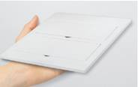 | 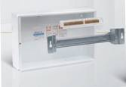
Cover | Box Base
Surface mounting box base is made of high quality cold-rolled plate,1.0mm thickness for one row and 1.2mm for two rows.Embedded mounting box base is made of high quality cold-rolled plate, 0.8mm for one row and 1.0mm for two rows.The surface of the plate is electrostatic powder coated and the tolerance is fully complied with the PT.A tolerance requirements in GB/t 708-2006.
Product way(embedded mounting):
4way,7way,10way,12way,14way,16way,18way,20way,24way,28way,40way.
Product way(surface mounting):
4way,7way,10way,12way,14way,16way,18way,20way,24way,28way,40way.

