Plastic empty enclosure for MCB IP65 (HT series) water proof distribution box
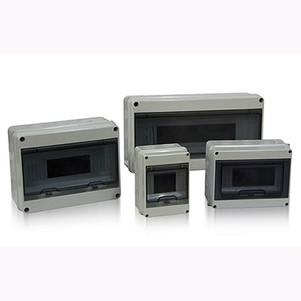
>> Introduction

HT Series lighting box is in line with IEC-493-1 standard, attractive and durable,safe and reliable, which is widely used in various places such as factory, mansion,residence, chapping center and so on.

>> Features
· Panel is the ABS material far the engineering, high strength, never change color,
the transparent material is PC.
·Cover push-type opening and Closing
Face covering of the distribution box adopts the push一type opening and closing
mode, the face mask can be opened by pressing lightly, the self-locking
positioning hinge structure is provided when opening
· Wiring design of the power distribution box
The guide rail support plate can be lifted to the highest movable point, it is no
longer limited by the narrow space when installing the wire. To install easily, the
switch of the distribution box is set up with the wire groove and wire pipe exit-
holes, which are easy to use for a variety of wire grooves and wire pipes.

>> Outline dimension
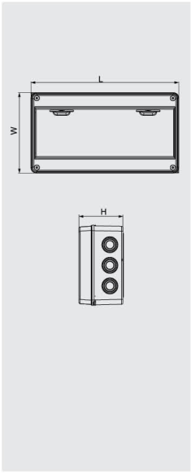 | 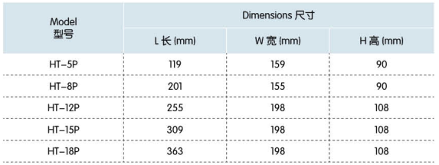

>> Packing information
HT waterproof distribution box |  |  | Carton  L*W*H（cm) | （PCS/CTN） | G.W.（kgs/ctn) | N.W.（kgs/ctn)
HT-5 120x160x95 | 5 way |  | 48*34**49 | 40 | 13 | 11.9
HT-8 200x155x95 | 8 way |  | 53*43*48 | 30 | 14.2 | 13.2
HT-12 250x195x110 | 12 way |  | 57*41.5*53.5 | 20 | 16.3 | 15.3
HT-15 310x195x110 | 15 way |  | 59.5*33*63 | 20 | 18.5 | 17.5
HT-18 365x195x110 | 18 way |  | 59.5*38.5*63 | 20 | 20.4 | 19.4
HT-24 360x280x110 | 24 way |  | 59.5*38*58 | 10 | 14.6 | 13.6

>> High-strength cartons, good for long-distance export transport
